FIRST INSPECTION REPORT

INSURED/POLICYHOLDER: Emily Brown

ADDRESS: 27 Maple Lane, Brampton, ON L6Y 4T2

INSURER: JKL Insurance

CLAIM #: CL3691

ADJUSTER/ CLAIM REP: TOP GUN

DATE OF INSPECTION: 2025-07-20

DATE OF LOSS: 2025-07-18

DATE OF REPORT: 2025-07-21

TYPE OF LOSS: SMOKE DAMAGE

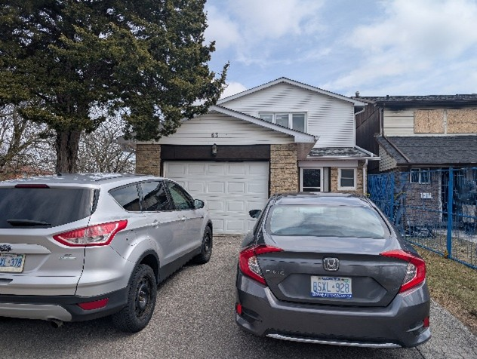

Image 1

**CAUSE OF LOSS:**

Kitchen fire in adjacent unit

**SCOPE OF WORK:**

The following is a brief outline of the work to be completed on the contents portion of this claim.

1. Assess, pack and move out all salvageable contents.

2. Inventory all the affected contents.

3. Inspect all affected electronics.

4. Restore salvageable contents.

5. Dispose of non-salvageable contents.

**RECOMMENDED RESERVES FOR TRINITY’S INVOLVEMENT:**

The estimated cost for Trinity’s involvement is as follows:

• Indemnity Work: Should not exceed $22,000.00 plus HST

Our actual cost will be adjusted once the exact scope of approved work is known. The recommended estimate is only based on visual inspection for reserves setting purposes.

• Trinity Listing & Pricing Expense Reserve: Should not exceed $4,500.00 plus HST

**RECOMMENDED RESERVES FOR THE TOTAL CONTENTS LOSS:**

Based on a visual inspection of the extent of non-salvageable items on the main floor, we believe that the total replacement cost for the non-salvageable items should not exceed $5,800.00 plus HST.

**CONCLUSION:**

Once our scope of work is approved, we can attend and begin the pack out process.

Thank You,  
  
Mo Waez  
Trinity Contents Management  
mo@trinitycontents.com  
(647) 613-2246

**KITCHEN & DINING AREA**

|  |  |
| --- | --- |
| Image 2 | Image 3 |
| Image 4 | Image 5 |

**LIVING ROOM**

|  |  |
| --- | --- |
| Image 6 | Image 7 |
| Image 8 | Image 9 |

**BEDROOM 1**

|  |  |
| --- | --- |
| Image 10 | Image 11 |
| Image 12 | Image 13 |
|  |  |

**BEDROOM 2**

|  |  |
| --- | --- |
| Image 14 | Image 15 |
| Image 16 | Image 17 |

**STORAGE ROOM**

|  |  |
| --- | --- |
| Image 18 | Image 19 |
| Image 20 |  |